SENG 410 – Senior Design Project 1

Requirements Document

SALEM

A Multi-Featured Smart Pet Feeder

Prepared by

|  |  |
| --- | --- |
| **Ugur Cem Ozturk** | *12070006006* |
| **Pelin Fidangul** | *12070001011* |
| **Ugur Ilter** | *13070006026* |

**Advisors:**

Korhan Karabulut

İbrahim Zincir

**November, 2016**

**İZMİR**

1. **What is Salem?**

Salem is a multi-featured smart pet feeder that basically determines the amount of food/water inside pet foods bowl in real-time and re-fills the bowl if necessary. This project will be helpful for the pet owners who want to feed their pets remotely. Additionally, for those who want to watch their pets in real-time, one of the targeted outcome is making a video stream through the webcam.

1. **Major Features**

* User defined weekly feeding schedule,
* Controlling levels of pet food and water inside the bowls and re-fill on need,
* Continuous live stream of animal,
* Controlling levels of pet food and water inside the storage and warn the user if below user specified level,
* Games and other features to keep the pet accompanied,
* Mobile and web interfaces for accessing to the system.

1. **Requirements**
   1. **Functional Requirements**

* User should be able to login to the web and mobile applications using credentials.
* User should be able to create new weekly feeding schedule.
* User should be able to edit existing weekly feeding schedule.
* User should be able to remove existing weekly feeding schedule.
* System should continuously live stream using a webcam.
* System should be accessible through both web browsers and mobile devices.
* System should automatically drop food and fill water in to the bowls according to the set schedule.
* User should be able to see the food and water levels inside the bowls.
* User should be able to see the storage levels.
  1. **Non-Functional Requirements**
* System should be able to recieve the amount of food and water data from load cells on the device.
* System should be able to re-fill the food and water bowls
* User should be able to create and edit feeding schedule via management panel on both mobile devices and web browsers.
* User should be able to see storage levels and details via LCD screen on the device.
* System should be able to store the data of credentials “**VE DIGER BILGILER”** in a database.
* System should be able to process the data of Authorization, live stream, scheduling process, checking storage levels and all other features through a server.
* User should be able to check storage information through the web and mobile applications.
* User should be able to stream live video and see the food and water levels inseide the bowls through a webcam.

Salem User Interface

Authorization: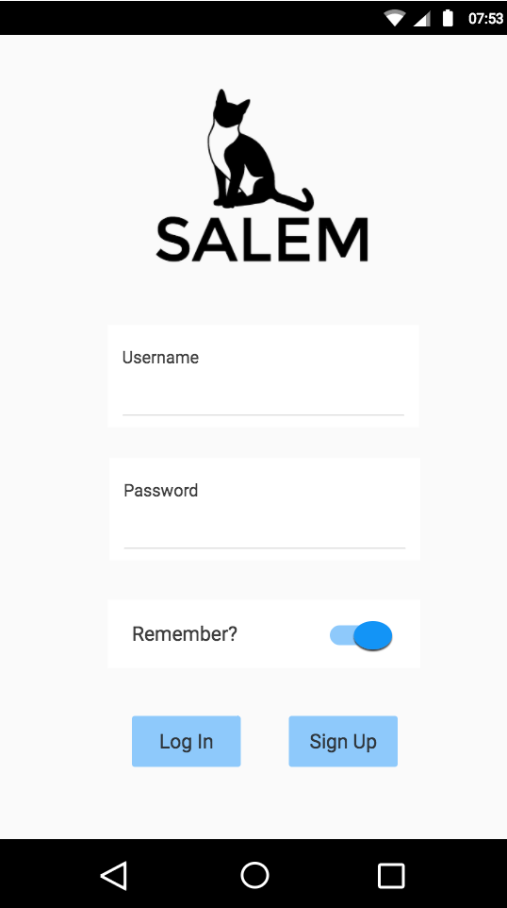

Salem log-in page.

It requires user credentials to login into system.

A ‘remember me’ button to save credentials into a local storage.

Main page: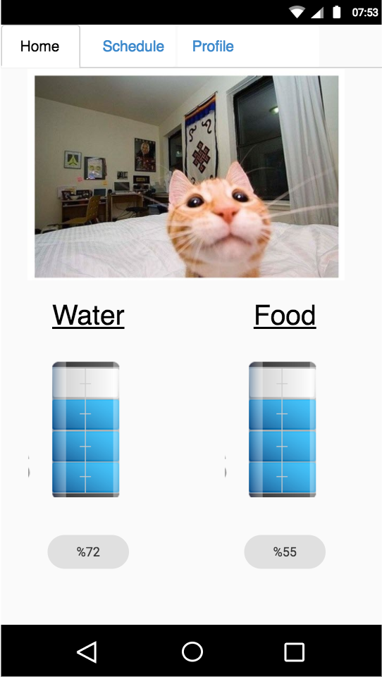

A fixed navigation bar after login for each page.

In main page, there is a live video stream panel on top of the screen.

Two storage icons that syncrhonized with food and water level. Down below, their level as a text.

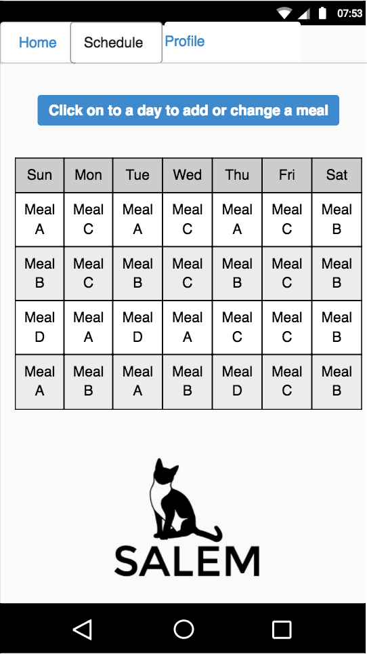Schedule:

select a meal:

A dropdown list will be shown when clicked on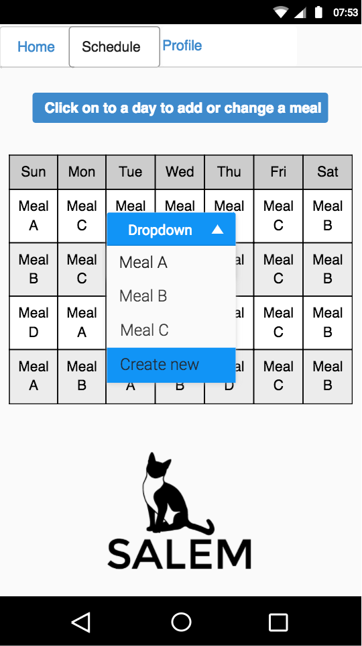 a day on the table.

create new meal:

